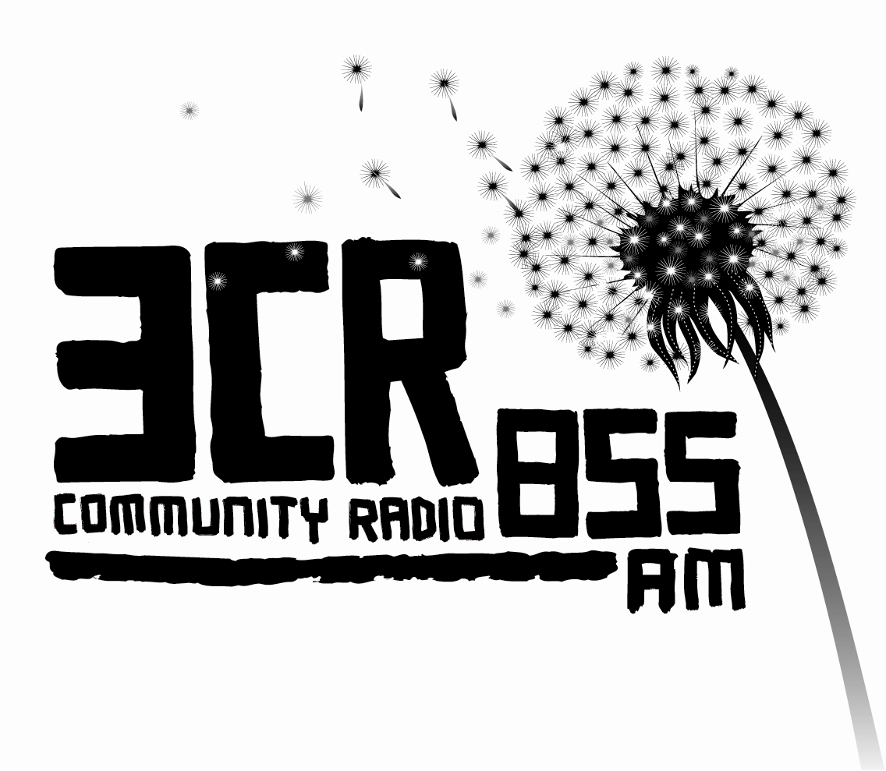

Media Release

Join the Resistance – Save Community Radio!
3CR Radiothon, June 2nd-15th, 2014

3CR 855AM | live stream via 3cr.org.au | 3CR Digital radio

Friday 2nd May 2014

As many thousands of people across the country mobilise against the Abbott government, 3CR Community Radio is asking its listeners and supporters of independent media to join the resistance by donating money to the station during our annual Radiothon.

The government has set its sights on the very existence of community radio with the National Commission of Audit recommending that all funding to the sector be abolished. And with Medicare, trade unions, Indigenous people, asylum seekers, pensioners and people with a disability all under attack, the scene is set for a tumultuous few years. It’s more important than ever, that stations like 3CR continue to thrive.

We need your help during our June 2-15 Radiothon.

“Our continuous broadcasting of diverse voices and programs is a vital part in the democratic process and a lifeline to communities”, says 3CR Station Manager Marian McKeown. “With the government signalling its intention to strip money from the sector, stations like 3CR become more reliant on their listening community to meet operational costs but at the same time, our function as the voice of the people and a source of news becomes more and more important.”

“3CR is well placed to provide a serious account of what’s happening in the world because our broadcasters are active participants in it. Our broadcasters are West Papuan freedom fighters, CFMEU officials, disability activists and East-West tunnel picketers. Our independence means we are able to provide news and analysis from the ground up, without worrying about what advertisers will think or what the ratings or opinion polls say because the issues we cover on-air are determined by people in the community.”

With a passionate crew of more than 400 volunteer programmers broadcasting 130 programs each week in over 20 languages, the station relies on its annual Radiothon to keep the station on air for the next twelve months, covering bills, license fees, equipment upgrades and a skeleton administrative staff.

Join the resistance – donate to 3CR and save community radio!

Make a tax-deductible donation online at www.3cr.org.au/support,
or by calling 3CR on (03) 9419 8377, or send a cheque or money order payable to ‘Community Radio Federation Ltd’ PO Box 1277 Collingwood 3066.

For more information or to arrange interviews with 3CR staff and programmers, contact
Station Manager Marian McKeown on 0402 049 461.

