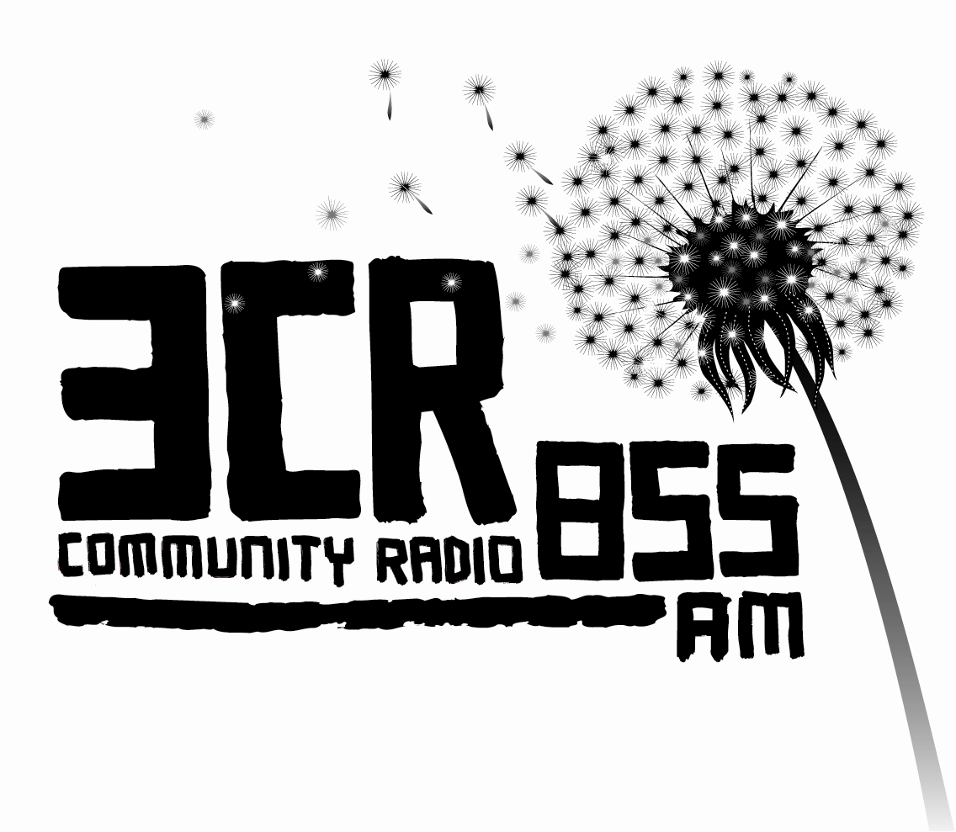
POSITION VACANT

POSITION DESCRIPTION: Program Coordinator
TERMS: 12 months (Maternity Leave Replacement) Subject to a three month probationary period.
HOURS: Full Time. 35 hours per week (9 day fortnight + RDO) Normal hours of work between 9-6pm.

RATE: $29.90 p/h + 9% Superannuation
Workers Agreement: Community Radio Federation Bargaining Agreement 2009.

Note for applicants: applications must address the key selection criteria.

3CR acknowledges that it broadcasts from land stolen from the Wurundjeri people, the original owners of the land where 3CR is located. The station also acknowledges that it broadcasts to land stolen from other members of the Kulin Nation in Victoria and to land stolen from Aboriginal people throughout Australia.

Mission Statement: The Station provides a voice for those denied access to the mass media, particularly the working class, women, Aborigines and the many community groups discriminated against by the mass media. 3CR actively discriminates in favour of Australian artists and composers.

Position Background
This position is full time position for 12 months maternity leave replacement. The role of the Program Coordinator is to manage all aspects of programming at the station including special programming such as International Women’s Day, Survival Day, May Day and NAIDOC week.

Job Description
- Co-ordination and development of all programming broadcast by 3CR with particular responsibility for programs broadcast on behalf of the station itself.
- Facilitate the work of the Programming Sub Committee, including arranging the agenda, organizing meeting times and producing minutes for the Committee of Management.
- Implement programming decisions of the Committee of Management of the Community Radio Federation.
- Monitor and develop program standards and develop new programming initiatives in accordance with 3CR’s philosophy.
- Ensure that all programs abide by both the broadcast law and the station’s internal broadcasting code.
- Other projects, including Radiothon and Subscriber Drive in conjunction with staff and volunteers and as directed by Committee of Management.
- Advise and assist all 3CR programmers.

Specific Duties
- Monitor and develop program standards.
- Ensure on air continuity of programs on 3CR on a daily basis.
- Liaise with Current Affairs Co-coordinator in relation to current affairs programming.
- Provide administrative support to the Programming Sub Committee
- Organize and co-ordinate programming for special events in consultation with the Station Manager.
- Maintain station program rosters.
- Work in consultation with Volunteer/Training Co-coordinator to organise advanced radio training.
- Maintain program files and archives.
- Liaise with record companies and performing rights bodies, and monitor the stations commitment to Australian Music content.
- Coordinate the cataloging and distribution of music at the station.

General Duties
Attend regular staff and Management Committee meetings; fulfill station access duties including supporting station volunteers and other duties as required.

Accountability
The Program Coordinator reports to the Station Manager and is employed by the Committee of Management of the Community Radio Federation.

SELECTION CRITERIA

ESSENTIAL

SPECIALIST SKILLS AND EXPERIENCE
- Understanding of and commitment to 3CR’s mission statement and a demonstrated commitment to progressive radio.
- Knowledge of 3CR’s Broadcasting Code, the Community Broadcasting Sector’s Code of Practice, and relevant media law.
- At least 3 years experience in community broadcasting.
- Demonstrated experience working with volunteers.
- Ability to negotiate Committee of Management decisions with programmers and to offer constructive feedback resulting from program review processes.
- Demonstrated experience in writing press releases, script for announcements and other promotional material for the station.
- Demonstrated experience in radio production
- Knowledge of radio production software, specifically audio editing software such as Cool Edit, on air playout system, web podcasting software

MANAGERIAL SKILLS
- Excellent communication skills and an ability to work co-operatively with others
- Effectively manage tasks and set priorities in order to achieve set objectives efficiently within set timelines
- Ability to work collaboratively and effectively with funding bodies, government agencies, other media and community organisations and the public in a positive and professional manner.
- Demonstrated experience in a diverse and largely volunteer supported organization
- Demonstrated understanding of cultural diversity and culturally appropriate organising.
- Demonstrated knowledge and experience of working with culturally and linguistically diverse communities, including Aboriginal and Torres Strait Islander communities

INTERPERSONAL SKILLS
- Highly developed communication and negotiation skills, including written and verbal presentation skills.
- An ability to coordinate and facilitate meetings.
- Ability to work independently and within a team.
- Problem solving skills and ability to propose solutions.
- Confidence to appropriately represent the station within the broader community.

DESIRABLE
- A working knowledge of content management systems for web and experience in maintaining and developing web content.
- Successful grant writing experience.

Applications:
Applicant must address the Key Selection Criteria in the application.
Applications to be submitted to the Station Manager marked ‘Confidential’.
Applications accepted via email stationmanager@3cr.org.au or to PO Box 1277 Collingwood Vic 3066

People from Indigenous, culturally and linguistically diverse backgrounds and people with disabilities are encouraged to apply.

Closing Date: Applications Close 5pm Friday 24th June.

