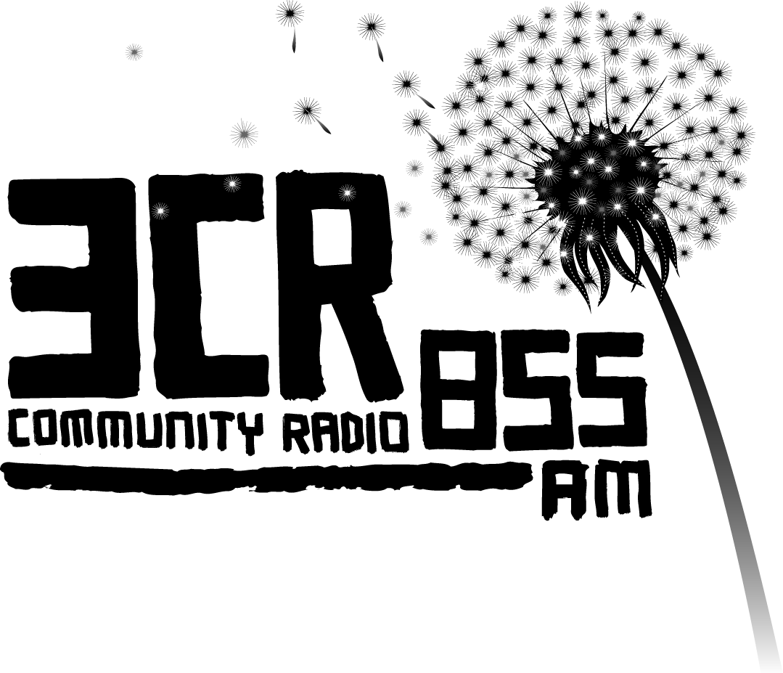
Mural Art Project 2010
Expression of Interest

The 3CR Mural Project will create an historical artwork in the heart of Fitzroy. The mural will reflect the rich Indigenous presence as well as the diversity of the local area. Artists Bindi Cole, Tom Civil and Reko Rennie with design and create the artwork and we’re looking for up to 10 young Indigenous people to work with them. Each participant will be granted a $100 Honorarium.

Applications due by 5pm Friday January 30th 2010.
Email to specialprojects@3cr.org.au or post/drop in to 21 Smith Street Fitzroy VIC 3065.

Name:...............................................................................................

Address:..........................................................................................

Phone Numbers:.............................................................................

Age:....................... * Email: .................................................................
*Parental Consent (if under 16 years of age)

Parent Name: .............................. Parent Signature: .......................

Contact Number: .......................

What inspires you to apply to be part of 3CR’s Mural Project?

.....................................................................................................................................................................................................................................................................................................................................................................................................................

What artistic experience or interest do you have?

.....................................................................................................................................................................................................................................................................................................................................................................................................................

Are you available to attend mural workshops on the weekend of February 20th and 21st 2010? (participants will be encouraged to attend at other times also if available)

.......................................................................................................................................

3CR will assess your application on Monday February 1st 2010
For more information call Juliet Fox on 03 9419 8377 or visit www.3cr.org.au

The 3CR Mural Project 2010 is funded by Arts Victoria and the Victorian Government through the Community Support Fund, the City of Yarra and JBSeed
