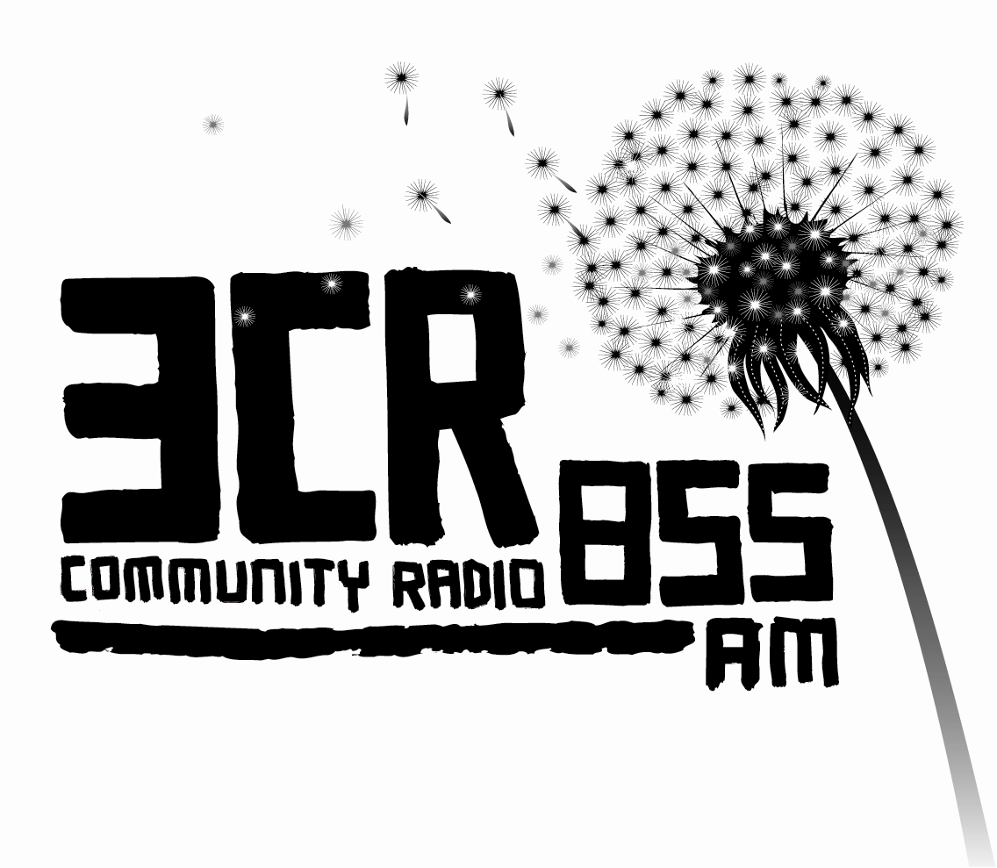
POSITION VACANT

3CR IT Worker 2011

POSITION DESCRIPTION

Acknowledgement
  - 3CR acknowledges that it broadcasts from land stolen from the Wurundjeri people, the original owners of the land where 3CR is located. The station also acknowledges that it broadcasts to land stolen from other members of the Kulin Nation in Victoria and to land stolen from Aboriginal people throughout Australia.

7.5 hours per week.
Pay rate: $36.40 per hour.
Period: 1 year contract

Position Background
The position is a fixed-term position the hours of work will be negotiated with the successful applicant.
The 3CR IT worker is required to manage and develop the hardware and software systems that are on site at 3CR studios at 21 Smith St Collingwood. They are required to maintain and develop IT and network systems, maintain servers and back up systems. 3CR maintains its IT system on a minimal budget, the Station broadcasts 24 hours a day with hundreds of users with diverse IT skills.

Please address the selection criteria in your application.

Duties:
- Act as the help desk for staff and volunteers with IT queries.
- Consult with the 3CR broadcast technician and website technical manager.
- Maintain and develop the 3CR network, ensure smooth running of antivirus software and printing services.
- Manage crisis situations, which may involve complex technical hardware or software problems.
- Manage accessibility issues within 3CR IT systems.

Selection Criteria
Essential
- Essential knowledge of Linux and Windows operating systems.
- Proven track record in desktop support and networking.
- Experience in basic hardware support
- Ability to work constructively under pressure and manage time efficiently.
- Ability to take direction and work with minimum supervision.
- Strong communication skills both verbal and written.
- Proven experience working with Indigenous people, people from a CALD background and women.
- Ability to communicate concepts to non-technical people.
- Excellent problem solving skills.
- Demonstrated experience with community organisations and volunteers

Desirable
- Good knowledge of 3CR
- Knowledge and experience with Drupal (CMS)

Applications
Please address the selection criteria in your application.
Applications to be submitted to the Station Manager marked ‘Confidential’.
Closing Date: 5pm Monday 23rd May 2011

  - Statement on Racism
3CR is committed to opposing racism. It supports the integration of cultural and linguistic diversity into the station, including broadcast content, volunteers, staff and management. People from Aboriginal, Torres Strait Islander, and linguistically and culturally diverse backgrounds are encouraged to apply for employment at the station.

People with a disability are encouraged to apply.

